INDIA LEARNHUB
Clarifications & System Walk-through
For your review and sign-off before development begins
Prepared by: Vidit Bhatnagar
For: Logan
Date: 19 April 2026
Estimated time to review: 20–30 minutes

Hi Logan,
Thank you for the detailed response to my requirements document — it gave me almost everything I need to start building India LearnHub. Based on your answers, about 80% of the design is now locked in.
This document covers the remaining 20%. There are a few questions where your answer needs one more pass, a few places where the choice you made has trade-offs I think you should see clearly, and a few visual walk-throughs of how things will actually work, so you can react before I start coding.
I have kept this document deliberately non-technical. Where I have made a recommendation, I have marked it clearly so you can simply say yes / no / prefer something else. Anywhere you see a diagram, that is what the finished system will behave like — please do push back if anything feels off.
Please reply with your answers to the Decisions I Need From You checklist on the last page. Once those are locked, I can begin development without further back-and-forth.
What's Already Locked In
These are confirmed from your response — I will not be asking you about these again.
Platform name | India LearnHub
Students & programs | In-person 300-hour Diploma Programs — Aviation and Retail & Fashion
Class size & scale | Max 30 students per class, target 126 admissions in first 30 days
Account creation | Admin creates all student accounts (no self-registration)
Online payments | Not in phase 1 — Finance team records payments manually
Fee components | Registration + monthly tuition + exam + certification + miscellaneous
Auto-suspension | After 2 weeks overdue, with 2 warnings first; Admin can override
Receipts | Auto-generated PDF receipts
Ticket categories | Academic, Administration, Finance, Technical, Complaints & Appeals
Ticket SLAs | 24 hours to acknowledge, 5 days to resolve, 15 days for formal complaints
Feedback style | Rubric + written comments + summary feedback (one-way)
Timetable | Weekly recurring schedule
Certificates | Yes — auto-issue on course completion via Certifier.io
WhatsApp notifications | Yes
Brand palette | Orange #F58220, Navy #1A3A8F, Light Blue #6E9BCC, Cream #FBF5E8
Infrastructure | Separate from AGI — its own database and server
Launch target | Testing in June, full launch in July
The System at a Glance
Before we get into the open questions, here is a one-page picture of what India LearnHub will look like. Five user types, each with their own dashboard.
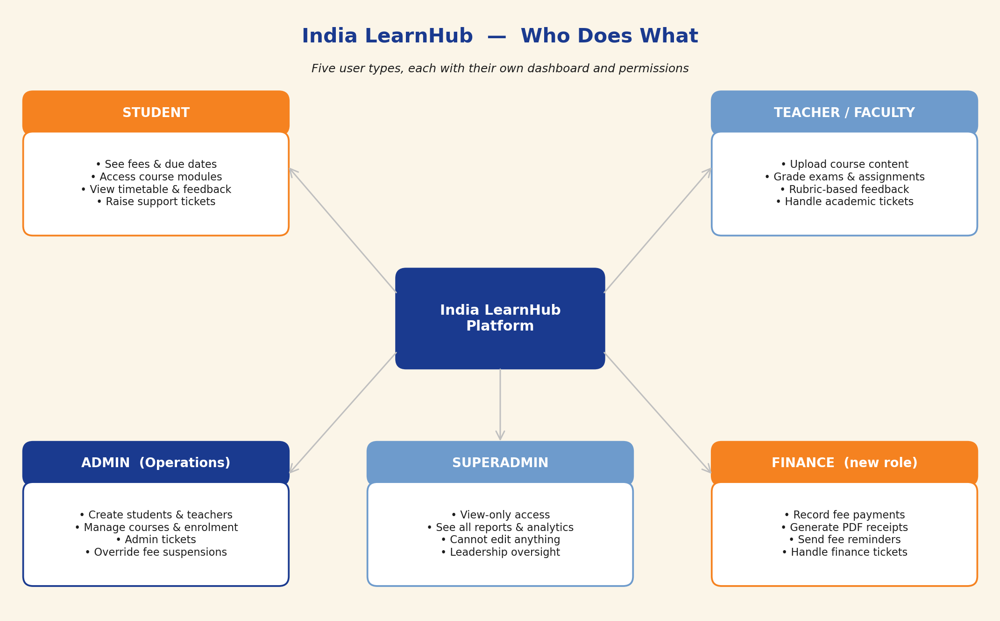
The Finance role is the one you asked me to add. Everyone else already exists in AGI, though the permissions and screens will be designed fresh for India LearnHub.

Clarifications Needed From You
Twelve questions in total. Most have my recommendation pre-filled — you can simply confirm or adjust.
Q1. Data privacy & compliance
Why this matters: In Q37 of the original response, the answer came back as the question text (probably by accident). I need to know if there are any legal requirements I must design around — e.g., must student data be stored within India, or do you have retention/audit rules from an accreditation body?
Options:
- No special requirements — data can be stored anywhere, no specific retention rule
- India residency required — student data must be hosted in India (affects server choice)
- Specific rules I should know — please describe in your reply
MY RECOMMENDATION: Option B (India residency) is the safe default for an Indian-market EdTech product, even if no rule explicitly requires it. It costs the same, but protects you if rules tighten later.
Your answer: We must comply with Digital Personal Data Protection Act, 2023 (DPDP Act), as far as I know this does not require data to be store in India but we should choose a service which is familiar with the act. __________________________________________________________
Q2. Mobile app — which flavour?
Why this matters: You said 'yes' to a mobile app. There are three ways to deliver that, each with different time and cost implications. A native iOS + Android app is a 1-2month project on top of the web build — too much for July. The two faster options still feel like an app to the student.
Options:
- Progressive Web App (PWA) — installs from the browser, works offline, sends push notifications, feels like an app. Built together with the web version — no extra time.
- Wrapper App in the App Store — same experience as PWA but published to the Apple App Store and Google Play Store. Adds about 4–6 weeks and needs Apple/Google developer accounts.
- Full native app — dedicated, polished iOS and Android apps. Adds 3–4 months. Not realistic for a July launch.
MY RECOMMENDATION: Option A (PWA) for the July launch — fastest, students can still 'install' it on their phones. If you later want to be listed in the App Store, we can upgrade to Option B in phase 2 without rebuilding.
Your answer: Option A_______________________________________________________________
Q3. Videos and PDFs inside courses
Why this matters: In the feature checklist you marked 'skip' for Video Player and Document Viewer, but 'include' for Course Access & Modules (which is the place where students watch videos and read PDFs). I believe you meant: students can still watch and read everything, we just don't need to track how long they watched or which page they're on.
MY RECOMMENDATION: I will build it this way: videos play, PDFs open, but no watch-time tracking or per-page tracking. Please confirm or correct.
Your answer: Correct_______________________________________________________________
Q4. Student batches — build the support now?
Why this matters: You said 'not sure yet' about batches. This is a database decision, not a feature decision. If I don't build batch support from day 1, adding it later means rewriting the student records — expensive. If I build it in, and you never use batches, every student just sits in a default 'Batch A' and you never notice.
MY RECOMMENDATION: Build batch support in from day 1. You get flexibility for free (morning/evening sections, campus splits, cohort-wise schedules) and pay nothing if you don't use it.
Your answer: yes, batches _____________________________________________________________
Q5. Domain name
Why this matters: India LearnHub needs a web address (e.g., indialearnhub.com) before it can go live. It needs to be purchased and pointed at our server at least 2 weeks before launch so the secure connection (HTTPS) and email sending can be verified. For a July launch, I need this locked by mid-May.
Options:
- Your team will register and share — you purchase the domain and give me access to configure it
- I register on your behalf — you reimburse the cost (~₹1,000 per year); domain stays in your name
MY RECOMMENDATION: Either works — just please confirm who owns this task and by when.
Your answer: Rejin says he has bought a few different domains that you know about that we can use. _______________________________________________________________
Q6. Finance role — exact permissions
Why this matters: You asked me to add a Finance role, which I'm doing. To make sure the permissions are right, here is what I'm assuming Finance can and cannot do.
Options:
- Finance CAN — view all students, record fee payments, issue PDF receipts, send fee reminders, see fee reports, handle finance tickets
- Finance CANNOT — create or edit courses, create or delete user accounts, access academic content, change student grades
MY RECOMMENDATION: Confirm the above split, or tell me what to adjust.
Your answer: Confirmed _______________________________________________________________
Q7. Complaint tickets — when can one be raised?
Why this matters: You said a Complaint ticket can only be opened if the student has raised another ticket first. I need one level of detail: must the earlier ticket already be closed/resolved, or can the student escalate while it's still being worked on?
Options:
- Stricter — earlier ticket must be Resolved or Closed before a Complaint is allowed — prevents impatient escalation
- More flexible — any earlier ticket (even Open/In Progress) is enough to unlock the Complaint button — faster for genuinely distressed students
MY RECOMMENDATION: Option A (stricter). Matches standard grievance escalation practice and stops Complaints from being used as a shortcut.
Your answer: Option A _______________________________________________________________
Q8. First-time login — the welcome email
Why this matters: When Admin creates a student account, what should the welcome email contain? The student needs to know where to go, how to log in, and what to expect.
Options:
- Temporary password — system generates a password, student changes it on first login
- Magic link — no password — student clicks a one-time link in the email that logs them in and prompts them to set a password
MY RECOMMENDATION: Option B (magic link). Fewer support tickets from forgotten passwords, better first impression, standard for modern EdTech.
Your answer: Option B _______________________________________________________________
Q9. Fee reminder schedule
Why this matters: You said auto-reminders for upcoming and overdue payments. Here is the schedule I plan to use. It aligns with the 2-warning-then-suspend rule you already confirmed.
Options:
- 7 days before due date — friendly upcoming-payment reminder (email + WhatsApp)
- On due date — gentle 'payment due today' reminder
- 3 days overdue — friendly nudge
- 14 days overdue — Warning 1 — formal notice that access will be suspended in 2 weeks
- 21 days overdue — Warning 2 — final notice
- 28 days overdue — Access suspended automatically
MY RECOMMENDATION: Use this schedule unless you want to adjust any of the timings.
Your answer: Add another reminder 14 days before upcoming payment is due, otherwise looks good. _______________________________________________________________
Q10. WhatsApp — what events trigger a message?
Why this matters: WhatsApp messages cost per message and each template needs to be pre-approved by Meta (1–2 days per template). The more event types, the more setup. Here are the events I recommend wiring up:
Options:
- Account created — welcome message with magic link (optional — email already covers this)
- Fee due — upcoming and overdue fee reminders
- Payment received — confirmation with receipt attached
- New feedback — faculty has given you new feedback
- Ticket updated — status change or response from staff
- Class schedule change — timetable update notifications
MY RECOMMENDATION: Start with Fee due, Payment received, and Ticket updated for launch. Add the rest in phase 2. This keeps WhatsApp costs low and templates manageable.
Your answer: Agree _______________________________________________________________
Q11. Receipt & invoice template
Why this matters: Every payment triggers a PDF receipt. I need to know what it should look like before I design it.
Options:
- Logo and address — please share the official India LearnHub logo (SVG preferred) and the registered office address
- Tax/GST details — if India LearnHub (or its parent LUC) has a GST number, should it appear on receipts? Is tuition GST-applicable or exempt?
- Signature — a digital signature of a finance/authorised person, or just a system-generated receipt number is fine?
MY RECOMMENDATION: Send me the logo file, registered address, and GST details (if any). I will design a clean default and share a preview for approval.
Your answer: PENDING _______________________________________________________________
Q12. Launch readiness — your team's side
Why this matters: A June test run and July launch only works if a few things from your side land in parallel with my development. I am not asking you to do any of these now — I just need to know who on your team owns each item so I can follow up with them.
Options:
- Logo & brand assets — final logo in SVG + PNG, plus any marketing banner or illustration assets
- Domain name — purchased and DNS-ready (see Q5)
- Content manager — one person from your side who will upload the first batch of course videos, PDFs, and rubrics
- Test cohort — 5–10 staff or students who will test the system during June before real students come in July
- Finance operator — the person who will actually use the Finance role — I may need a 30-minute walkthrough with them
MY RECOMMENDATION: Please share the name (and email) of the owner for each of the five items above.
Your answer: PENDING _______________________________________________________________

How Support Tickets Will Work
Here is the full picture of the ticket system once it's built. This captures all the rules you gave me — categories, SLAs, the complaint escalation rule, and the 7-day reopen window.
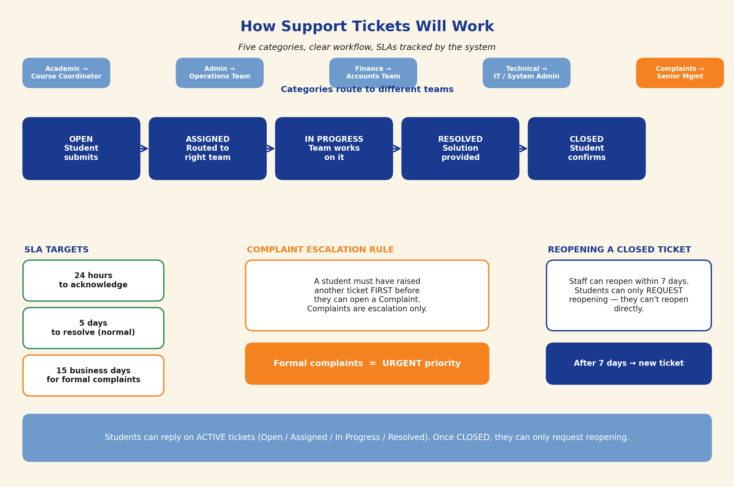
One thing to call out: the system will track SLA timers in the background. If a ticket approaches the 24-hour acknowledgement deadline or the 5-day resolution deadline without action, the assigned staff member and their manager both get a reminder. You will see an SLA-breach count on the admin dashboard, which is useful for staff performance reviews later on.

How Fee Collection & Auto-Suspension Will Work
This is the automatic rhythm the system will follow for every student's fee installment. Payment is recorded manually by Finance; everything else happens on its own.
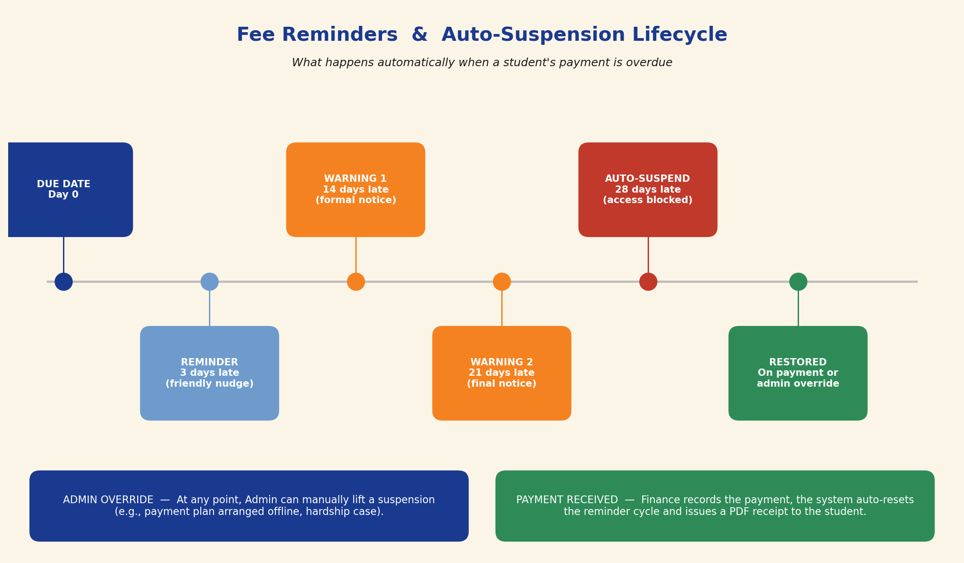
When Warning 1 or Warning 2 is sent, it includes the outstanding amount and a deadline. When access is suspended, the student can still log in to see their fees page and raise a finance ticket, but course content and timetable are blocked until payment is recorded or an admin override is issued.

Scope vs Timeline — An Honest Note
You asked for testing in June and full launch in July. Looking at the full feature set, that is achievable — but only if a few scope decisions go the right way. I want to be upfront about where the risk sits so there are no surprises in June.
What makes the timeline work
- You skipped the heaviest AGI features (Voice AI, Flashcards, AI Quiz Generation, Live Class Scheduling). This saves roughly 4 weeks of development.
- You chose manual payment recording over a payment gateway. This saves another 2 weeks (no gateway integration, no refund flow, no reconciliation).
- You are keeping the Certifier.io integration as-is, which means we reuse proven code from AGI.
Where the timeline gets tight
- A native mobile app is not realistic for July. This is why I am recommending a Progressive Web App in Q2.
- The ticketing system has five categories with different routing, an escalation rule, and SLA tracking. It is not complicated, but it is not small either — roughly 2 weeks of build + testing.
- The fees module (with warnings, auto-suspension, and PDF receipts) is the most state-heavy part of the system. 2 weeks.
What I will NOT compromise on
- The data model — I would rather take a day longer to get the database structure right than ship a June test with a schema I will have to migrate later.
- Security — Argon2id password hashing, audit logs on finance actions, rate limiting on login attempts. These are non-negotiable and already patterns I have built before, so they do not cost extra time.
- The final UX pass before launch — 3 full days after everything is functional, just for polish and copy. Non-technical users notice UX far more than features.

Proposed Phasing
I recommend splitting delivery into two phases. Phase 1 ships everything you need for the July launch. Phase 2 picks up the nice-to-haves once India LearnHub is live and earning.
PHASE 1 — June test, July launch | PHASE 2 — August to September
• Login, 5 roles, admin-created accounts | • Native iOS / Android apps (if still wanted)
• Student dashboard, course modules, timetable view | • Online payment gateway (Razorpay / Stripe)
• Fees dashboard, manual payment recording, PDF receipts, auto-suspension | • Advanced analytics and custom reports
• Full ticketing — 5 categories, SLAs, escalation rule | • Parent / sponsor portal (if you want one)
• Faculty feedback — rubric + written + summary | • AI features you skipped, if demand emerges
• Exams, manual grading, Certifier.io certificates | • Deeper WhatsApp automations
• Email + WhatsApp notifications (core events) | • Bulk operations (bulk enrolment, bulk fee collection)
• Progressive Web App (installable on phones) | •
• Admin dashboard with analytics | •

Decisions I Need From You
One-page summary — please write your answer in the right-hand column and send this back. Short answers are fine; 'Agreed' is fine where you accept my recommendation.
# | Question | Your answer
Q1 | Data privacy — any India-residency or retention rules I should design around?
Q2 | Mobile app — confirm Progressive Web App for launch, native later?
Q3 | Confirm: videos play and PDFs open, but no watch-time or page-tracking?
Q4 | OK to build batch support in from day 1 even though batches aren't decided?
Q5 | Who owns domain registration, and by what date?
Q6 | Confirm the Finance role's CAN / CANNOT permissions list?
Q7 | Complaint tickets — stricter (earlier ticket must be closed) or flexible?
Q8 | Welcome email — temporary password or magic link?
Q9 | Confirm the 6-step fee reminder schedule?
Q10 | WhatsApp events — confirm Fee Due + Payment + Tickets for launch?
Q11 | Logo file + registered address + GST details — can you send by when?
Q12 | Five owners for logo / domain / content / test cohort / finance operator?
Once I have your answers, development starts the same week.
Thank you, Logan.
— Vidit

